Analysing the writing diet of engineers

Muhammad Nadeem
Dept. of Electrical and Computer Engineering
The University of Auckland
Auckland, New Zealand
muhammad.nadeem@auckland.ac.nz
Marion Blumenstein
Centre for Learning and Research in Higher Education
The University of Auckland
Auckland, New Zealand
m.blumenstein@auckland.ac.nz
Morteza Biglari-Abhari
Dept of Electrical and Computer Engineering
The University of Auckland
Auckland, New Zealand
m.abhari@auckland.ac.nz

Abstract— Writing has long been seen as a tool to develop communication skills. Engineers spend a considerable amount of time in communicating with technical and non-technical audiences when on work. Due to high demands of good technical writing skills, special measures are taken by most engineering faculties and engineering educators for fostering such attributes but writing skills for non-technical people is often over looked. A vast majority of students stumble into writing with an inadequate sense of the importance of their audience – a problem that is hard to solve. This introductory study analyzes the engineering students’ writing when addressing the non-technical people. We conducted short writing exercises in a third-year engineering course aiming at pitching an idea to non-technical audiences with a view to assess their ability of adapting their writing according to the audiences. These writings are analyzed using the freely available text analyzing tools. The analysis revealed that students’ writings are complex and tend to address the more qualified people than the general audiences. The initial findings provide enough encouragement to further explore this topic and provide a basis for related practitioners to address this issue and develop strategies to overcome this issue.
Keywords—writing practice, engineering education, peer assessment, communication skills, and teaching/learning strategies.

Introduction
The demand of engineers is continuously growing since the middle of the second century due to rapid developments in science and technology. Writing is an essential soft skill for every aspiring engineer as most of the companies are owned by rich investors who find it hard to communicate technical information in a way that is easily understood by their audiences. This is as important as developing a product and hold value to both engineers and their companies. Therefore, engineers need to possess good communication skills which allows them to transmit information effectively and adds tremendous value to their career. The impressive work produced by engineers is useless unless it is communicated to others in a way that they understand.
Communication skills are important attributes for today’s engineering graduates [1] which is one of key outcomes required by an undergraduate engineering programme under the ABET Engineering Criteria 2000 [2] and Washington Accord accreditation standards for Engineers [3]. These accreditations demand that engineering programs must assess students’ technical skills but also the professional skills such as effective oral and written communication.
Engineers usually work on large and complex projects which requires integration of many groups spread across the component of design as well as the customers and suppliers. Each group comprises engineers with diverse skills carrying out different activities. A study conducted by Crabtree et. all (1993) reported that information gathering and documentation eats up over 43% time of a design engineers and also these activities are ranked most frustrating ones at the job. Similarly, a longitudinal study of a single cohort of university engineering graduates providing detailed information on the early career of Australian engineering graduates reveals that about 60% of the time at work is spent on interactions with other people either face to face, on the telephone, or through written documents [Trevelyan, 2008 #42]. More precisely, engineers across all disciplines, spend more than 25% of their time in writing document. Australian manufacturing engineers were found spending over 70% of their time on documentation-related activity (H. McGregor & McGregor, 1998). Youngman and colleagues quoted a 1975 study on 1300 engineers keeping detailed time records, revealing 60% of their time was spent on direct communication activity (1978). There are many other research studies that have reached similar conclusions with the total reported time on direct communication activity ranging from 45% to 75% (e.g. Kilduff, Funk, & Mehra, 1997; Tenopir & King, 2004). Poor communication is said to be the reason behind some of the most catastrophic engineering failures such as the Space Shuttle Challenger disaster (1986) and loss of the NASA Mars Climate Orbiter (1999).
Engineers do a lot more writing than what is assumed by rest of the world. Effort of an engineer is not complete until the documentation outweighed the final product. Good writing skills bring a lot of benefits to the engineers. It improves their prospects of landing a job as good writing skills help in creating a compelling cover letter and writing style is one of key factors that influences the decision of hiring experts. Good writing skills also allow them promote themselves through presenting their work and achievements to the people all over the world through blogging aiming for broad audience which requires communicating in a manner that is easy to understand. It also help you to communicate your ideas and business case with the management. This helps you to write the contents in a compelling fashion that will convince the company management and consequently, it will secure your job. This will also make it easier for you to explain your ideas to your manager and elaborate all the benefits your project brings to the company. It also helps engineer creating various documents at the work place which include technical documentation, specifications, system requirements, manuals, warranty restrictions, and other parts of product documentation intended for third-party individuals, users, or technical support. Writing skills also help in communicating with different divisions in the company as they work with various departments in the company such as sales, marketing, and other divisions that are not inhabited by engineers and technical staff. Much of the internal communication goes via emails and good writing skills allow you to create clear emails that are easy to understand, which makes the job easier for other members of the company. Lack of written communication skills at the workplace can also have negative effects on stress levels, deadlines, morale, and health, which in turn can lead to misinterpretations adversely affecting the problem resolution capability resulting in time wastage and inefficiency at work.
Engineers often find it hard to express themselves concisely and logically by writing English text as most of the time they work with mathematical derivations, equations, and programming. As a result, students get proficiency in writing mathematically consistent equations and expression where the logic is embedded in the language itself but in real-world logic has to be explained using the words. Writing concisely and logically about the real-world concepts in English is an entirely different skill which is difficult to master and engineers are no better than the majority of other people [Carper, 2017 #40]. They feel challenged when it comes to the words and often find themselves disadvantaged when they present the logical arguments to the decision-makers who are often good at words [Trevelyan, 2014 #41]. Many engineers need to master the ability to reason concisely and logically using the language their audience can understand. Undergraduate level engineering courses do not really target to develop this capacity in the students. Therefore, engineering students need to develop the habit of listening and understanding other people and they learn how people think so that can communicate at their level. Engineers are good with Also, it the business cases are presented to the people who do not have the much technical background and it is important to communicate the benefits of the proposed project or idea to the management in an effective way which is easy to understand.

Engineers produce many kinds of writing during their academic as well professional writing which includes: notes during class sessions, lab reports, written assignments, term papers, e-mails, presentations, memos, proposals, and messages for which students have a clear writing objective and audience (Ludlow and Shulz 1994; Buzzi et al. 2012). Therefore, university education should help students to learn the specialized register of the engineering profession which not only affects the success as a student but also as a professional. This also increases access to the information and also the ability to participate in varying communities. This is an important skill which needs attention for smoothing the critical transition phase of students from undergraduate education to either the workforce or graduate school. Engineers often think that they need to explain the assumptions briefly as mathematical equations are self-evident which are interpreted by the senior engineers who are more knowledgeable and verbal reasoning is loose. Therefore, simple logical connections are missing in the writings of engineers. Although, these connections are obvious to engineers but not to the other people and hence need further explanation.
Engineers often have to deal with the uncertain of incomplete information as they hardly get complete written description from the client. Also when solving a problem, first step is to specify the problem in a clear and unambiguous way which is different from recognizing a need. The problem definition statement results from first identifying a need. Once a need has been established, engineers define that need in terms of an engineering design problem statement.

Furthermore, engineers need to speak to the rest of the world using different methods such ass emails, websites, advertisements, reports, budget requests, proposals, pitches, websites, manuals, FAQs, etc. If you do it effectively, you will be able to convince your customers otherwise you will mystify customers and end-users alike. Inability to write for a non-technical audience can dramatically limit the audience. The whole point is to make everything clear for your client. They aren’t developers. The reason I write as I learn? If I don’t understand something, they certainly won’t. I can either explain it to them from a new user perspective, or you and I can work to fix it before it reaches them. Writing above (or well below) the reader’s comprehension may produce a negative result, one counter to the writer’s intentions.

When writing, it is important to keep audience in mind as they are persons who actually be reading your document, or receiving your emails. Engineers usually make the mistake of ignoring the audience. They have to write different documents which are read by the different audiences. Therefore, it is important to keep your audience top of mind as it will change the way they will write the document. A good document is the result of a complex process that factors in readers and their knowledge. In industry, engineers are required to write for a large, diverse audience all with different informational needs and expectations for a report. Sometimes the complexity of your idea could not be read by non-technical personnel without proper wording that is easy to understand. They are likely to be much less familiar with the technical details and they may act on, or be affected by, the report. The student’s ability to explain the concepts in an easily understandable language is also an indication of the fact that he has good grasp of the subject. If student is uable to explain a complex technical concept in non-technical terms, his understanding of the technical concepts may be questioned.
This small-scale study reported here contributes to our engineering communication awareness by providing information about engineering students’ ability to write while keeping in view the audiences. It was motivated by the following research questions:
- Do undergraduate students have the ability to write for non-technical audiences?
- What kind of professional writing experiences have students had outside of the classroom?

Theoretical Framework
There is a trend of incorporating more and more writing exercises to support wider variety of learning outcomes. Writing exercises are used to achieve deeper level of understanding (Hanson and Williams 2008; Venters et al. 2014; Goldberg et al. 2014), enhance students’ critical thinking skills (Reynolds et al. 2012, Clayton 1996), to identify learning bottlenecks and misconceptions (Wilson 1986), and assess and evaluate student learning and understanding in ways that cannot be tested with simple calculation-based questions (Wheeler and McDonald 2000). These engineering classroom activities are closely aligned with the broader Writing Across the Curriculum (WAC) movements (Manuel-Dupont 1996; Ford and Riley 2003) according to which writing is the responsibility of the entire academic community. Also, writing instruction must be continued during all four years of undergraduate education as it promotes learning. Writing assignments are designed to support the goals of Writing in the Disciplines (WID) as it is aimed to gain familiarity with genres and it is used by a large number of WAC programs, although not precisely as these writings are short. The writing assignment is combined with Writing to Engage (WTE) as it allows students to practice in critical thinking as well as engages them in critical thinking.

Discourse Theory
The language can be divided into different levels such as Phonology, morphology, semantics, syntax, and discourse (craig, 2008 revealing mind). Discourse can be defined in different ways such as: a conversation or text, collection of texts or conversations, a shared way of talking or creating texts (code), codes, languages, and ways of speaking of a topic. According to Cambridge Delta, any connected piece of speaking or writing is referred to as discourse. Discourse Analysis is the study of how the separate ‘bits’ of language which make up the discourse are connected in such a way that the discourse makes sense. In case, if it doesn’t make sense, discourse analysis enables us to find out why.

Readability and readability Test
According to Wikipedia, Readability is the ease with which a reader can understand a written text. Easy reading helps learning and enjoyment, so what we write should be easy to understand. In natural language, the readability of text depends on its content and its presentation [Dale, 1949 #43]. Readability tests are formulae used to evaluate the readability of a text. There are many (more than 17) significant measurable style variables used to measure the readability of the text and most commonly involves counting syllables, words, and sentences. Readability tests are often used as an alternative to conducting an actual statistical survey of human readers of the subject text (a readability survey). A list of readability test is provided in Table I.
Writing is analyzed using freely available online text content and readability analyser tool, called Analyze my Writing. The output of the tools is readability index which is an estimation of how difficult a text is to read which is based on text's complexity. The attributes of writing which are measure include: word lengths, sentence lengths, syllable counts, and so on. There are many index available for indicating the complexity of the writing which differ in their working and each emphasizes particular aspects of text complexity. Some emphasize syllable counts while others look only at word and sentence lengths. But, all are based on the same core idea; readability is essentially a measure of text complexity. Plung has advocated the application of the readability formulas for the writings (even technical) if they are intended for the general public. A list of available readability tool is given below:
- writing analysis tools and readability tests
Writing Analysis Tools | Readability Tests
- Analyze my writing  - Joes web tools  - ReadablePro  - The writer’s diet  - Text Content Analysis Tool  - Hemmingway Editor | - The Flesch formulas  - The Dale–Chall formula  - The Gunning fog formula  - Fry readability graph  - McLaughlin's SMOG formula  - The FORCAST formula  - The Golub Syntactic Density Score  - The George Klare studies  - The John Bormuth formulas  - The Lexile framework  - ATOS readability formula for books  - CohMetrix psycholinguistics measurements

The application of a useful readability test protocol will give a rough indication of a work's readability, with accuracy increasing when finding the average readability of a large number of works. The tests generate a score based on characteristics such as statistical average word length (which is used as an unreliable proxy for semantic difficulty) and sentence length (as an unreliable proxy for syntactic complexity) of the work.
Some readability formulas refer to a list of words graded for difficulty. These formulas attempt to overcome the fact that some words, like "television", are well known to younger children, but have many syllables. In practice, however, the utility of simple word and sentence length measures make them more popular for readability formulas.[citation needed] Scores are compared with scales based on judged linguistic difficulty or reading grade level. Many readability formulas measure word length in syllables rather than letters, but only SMOG has a computerized readability program incorporating an accurate syllable counter.

Tone analysis
Tone refers to an author’s use of words and writing style to convey his or her attitude towards a topic. The author feels about the subject is often defined as the tone which is different from feels is referred to as the mood. Tone should not be confused with voice which is author’s personality expressed in writing. It is hard for author to alter his personality but he can adjust his attitude (tone) which can affect the mood of audience’s.
Tone is conveyed through diction (choice and use of words and phrases), viewpoint, syntax (grammar; how you put words and phrases together), and level of formality. It is the way you express yourself in speech or writing. In formal writing, your tone should be clear, concise, confident, and courteous. The writing level should be sophisticated, but not pretentious.
A writer's tone is very important, as it conveys a particular message from you as the writer and likewise affects the reader in a particular way. Consequently, it can also affect how the reader receives the message you are communicating. The description of few of the tone is provided below:
- Analytical: A person's reasoning and analytical attitude about things. A writer's reasoning and analytical attitude about things. Higher value, more likely to be perceived as intellectual, rational, systematic, emotionless, or impersonal.
- Tentative: A writer's degree of inhibition. Higher value, more likely to be perceived as questionable, doubtful, limited, or debatable.
- Confident: A writer's degree of certainty. Higher value, more likely to be perceived as assured, collected, hopeful, or egotistical.
- Sadness: Likelihood of writer being perceived as sad. Low value, unlikely to be perceived as sad. High value very likely to be perceived as sad.
- Joy or happiness: It has shades of enjoyment, satisfaction and pleasure. There is a sense of well-being, inner peace, love, safety and contentment.
- Anger: Likelihood of writer being perceived as angry. Low value indicates unlikely to be perceived as angry. High value indicates very likely to be perceived as angry.
- Fear: Likelihood of writer being perceived as scared. Low value indicates unlikely to be perceived as fearful. High value, very likely to be perceived as scared.

Writing Activities
This teaching methodology was incorporated into a third-year of computer systems engineering course in the form of in class simple writing exercises which had been perceived well by the previous year students. These activities were incorporated in a Digital System Design I course. This course focuses on digital Systems implementation technologies with emphasis on hardware description languages and design abstraction levels; structural, architectural and behavioral modelling; register-transfer level design; datapath and control units; functional and timing simulations; FPGA-based implementation design flow and case studies.
Design Flow is a term used to describe the various design phases of an Integrated Circuit (IC) design. The design is usually based on the specification, assuming that they are provided, the most general approach adopted is shown in the Figure? The informal specification of a digital system are provided by some tender documents which are usually given in a human readable text or presentation format. These informal specifications are produced by an engineer working in a professional environment. Unfortunately, in the academic environment, students are often provided with the informal specification of a digital system and they never get chance to go through the two important steps of idea creation and communicating its effectiveness and finally writing down the informal specification of the system.
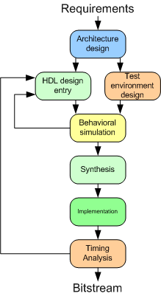
Figure 1: FPGA design flwo

The objective the writing exercises is to complete the design flow of a digital system. The FPGA design normally starts with the architecture design and steps of problem identification, devising a solution and writing specification are missing. It means they seldom get a chance of going through these important steps of identifying the existing problem to be solved and they only work with the provided specification. The writing exercises are designed to fill the gap identified. Furthermore, the idea for a project comes from inspiration, research, observation, and somebody’s comment. Therefore, this activity also helped students in developing aforementioned attributes.
The objectives of these exercises were to:
- Analyze the students writing and find out that whether it suits to the audience.

There were a total of four short writing exercises and related one is as described below:
Think of a real-world digital system which could be used to solve an existing problem in the community. You are required to identify the problem, suggest a title for the project and describe how it may benefit the community. Your description should be between 100 – 200 words, strictly. This activity will be peer-reviewed and marked by at least two other students.
This activity was mainly a practice of pitching an idea for students by answer following simple questions:
- What is it (idea)?
- What might the product/service do?
- What problem might it solve?
- Who will use it?
- What is valuable to the user?
These pieces of writings can be termed as creative writing which require saying things in words that create illusions or that establish a mood or other desired affects. The students were meant to complete the writing exercises during the lecture time. To ensure equitable access to learning activities and respecting students’ time commitments with other engagements, students were allowed to complete the activities after the lecture. As a requirement of the course, it was not compulsory for students to complete the activities but it did carry some very low percentage of marks as a reward for motivating them. The writings were submitted electronically by the submitted which were graded and feedback was provided to students. The feedback was provided using corrective marks and marginal notes. Corrective marks denoted simple word- or phrase-level errors and marginal notes highlight specific issue in the writing.

Methodology

Background
The aim of this study is to understand more about engineering’s writing style and their ability to adapt the tone of the writing according to the audience. An underlying assumption that has informed our thinking about engineering work is that writing is an essential component throughout the career of an engineering. This inquiry examined a third-year engineering course consisting of computer systems engineering students for two consecutive years. The main aim of this research was to assess the students’ ability to writing for different audiences as well as fill in the gap in the understanding of the Digital System Design course. It is a 15-point medium/advanced course in digital system design intended at Year 3 students of a four-year undergraduate program at the Electrical and Computer Engineering Department. It builds upon the knowledge and skills acquired in Fundamentals of Computer Engineering; a prerequisite of this course taught in the second-year. The objective of this course is to give the students the theoretical basis and practical skills in the design of medium size modern digital systems using Field Programmable Gate Arrays (FPGAs).

Sample
The main data of this study consisted of a total of ~ 82 short pieces of freewriting samples composed by participants in response to aforementioned activity 1A. The participants were undergraduate students from a large metropolitan university in New Zealand participated in the study (15 females; 45 males; average age 21 years). All participants were enrolled in a Year 3 Digital System Design I course and received no course credit for participating in the experiment. Participants represented an undergraduate discipline of Electrical and Computer Engineering. Non-technical writings were conducted over two consecutive years (2018-2019). The length of these writing samples ranged between 130 and 350 words.

Methods
This is an exploratory study investigating students’ perceptions on whether embedded writing exercises enhanced their conceptual understanding of real-word problems through writing and peer review. A cross-sectional questionnaire consisted of six closed questions (Likert type scale) and also included three open-ended questions. The quantitative data was summarised using descriptive statistics whilst the text responses were analysed in NVivo v 11 software (QSR) using a general inductive approach for analysing qualitative open-ended response data [32]. An open coding scheme was followed by thematic categorisation, during which similar conceptual categories were merged in order to create larger concepts.

Evaluation
Technical and professional literature found in scholarly journals generally scores above 12. Accordingly, texts which are meant to be accessible to a wide adult audience should fall somewhere between 8 and 12. Advertising copy is written anywhere from a 5th to 8th grade level depending on the market.
Writing is analyzed using freely available online text content and readability analyser tool, called Analyze my Writing. The output of the tools is readability index which is an estimation of how difficult a text is to read which is based on text's complexity. The attributes of writing which are measure include: word lengths, sentence lengths, syllable counts, and so on. There are many index available for indicating the complexity of the writing which differ in their working and each emphasizes particular aspects of text complexity. Some emphasize syllable counts while others look only at word and sentence lengths. But, all are based on the same core idea; readability is essentially a measure of text complexity.

Measure
Since this was an intervention study, it required the approval of an ethics committee. This study has received ethical approval from the Human Participants Ethics Committee from the University of Auckland (Reference No.: 018848). During the first lecture, the principal investigators explained to all students about the writing exercises and addressed their concerns.

Results and Discussion

We analyzed all the writings using freely available tool, Analyze my Writing. The score for 5 most widely used readability test is shown for individual writings in Figure and. The score for five readability tests are: Gunning Fog (Max.=19.63, Min.=7.29, Mean=13.50, Std. Dev.=2.49) Flesch-Kincaid (Max.=16.52, Min.=5.33, Mean=10.90, Std. Dev.=2.31), SMOG (Max.=16.65, Min.=7.49, Mean=12.30, Std. Dev.=1.78), Coleman-Liau (Max.=14.77, Min=6.18, Mean=10.72, Std. Dev.=1.82), and Automated (Max.=18.60, Min.=6.26, Mean=13.50, Std. Dev.=2.79).

Following Figure provides the maximum and minimum score for the writings for all five readability test. This indicates that some of the students are writing at much higher level than the other. For example, considering the Gunning fog test, the writings span between 7th grader to a person with nineteen years of formal education.
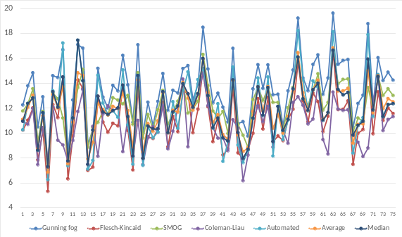
Figure 2:
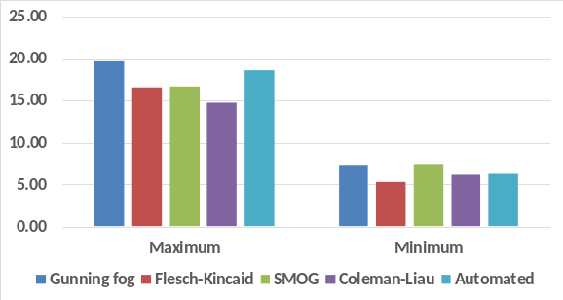
Figure 3:
The following Figure provides the average for each test for all writing and overall average. This indicates that on average, students writing target the audience grade 11 – 14.
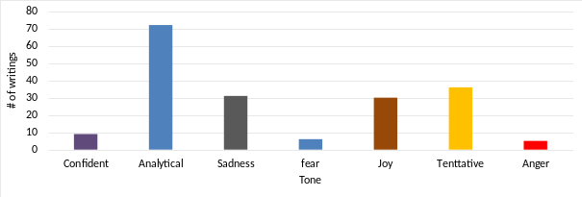
Figure 6:

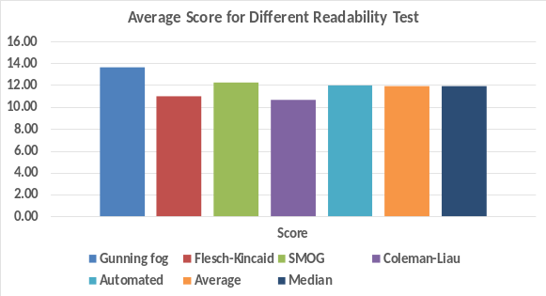
Figure 4:
Around 56% students’ writing were in suitable range for the audiences and 4% writing were too easy. Around 40% of the students’ writing were not suitable for targeted audiences. This is in accordance with Winsor finding that engineering students do not think that they are arguing for an interpretation or convincing an audience when they write but believe instead that they are conveying data or describing reality. This can be improved by providing useful feedback or they can learn on job by interacting with real audiences. In this way, the students become more and more aware of audience and tune their writing to suit them based on the feedback provided by them.
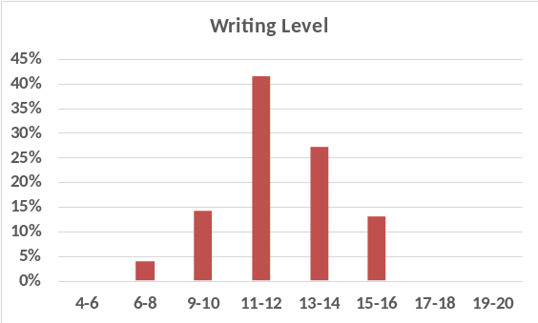
Figure 5:
We analyzed the tone of all 79 writings as shown in the Figure xx. Majority of the writings have analytical tone which was expected as it contains the reasons or logic/ justifications to support the idea presented. This also indicates that students analyzed an issue, presented the pros, and compares two scenarios (situation before and after suggested solution) and indicated why presented idea is better etc. It is required from the engineering students that they discard the colloquial write and embrace a more professional, analytical tone. It is preferred that they use precise language, sound confident, avoid unfamiliar language, prioritizing clarity, and get rid of filler words.

Around 36 writing pieces have tentative tone because students are cautious intheir claims as they are not proven or established beyond doubt or debate. There are 8 writings which have confident tone and majority of which came from high performance students. This raises a research question if there is any correlation between performance of students and the tone of their writing which need further exploration. Also, it is recommended to avoid boast about inventive imagination and calibrate the communication by striking a balance between expressing extreme confidence in idea and humility in creative genius.
. Other dominant tones are “sadness” and “joy” which can be due to the type of problem being address. The ideas focused on minimizing human miseries have “sadness” and, on the other hand, ideas improving quality of life or adding luxury have “joy” tone. Also, these are ccreative writings it is bound to say things in words that create illusions or that establish a mood or other desired affects.
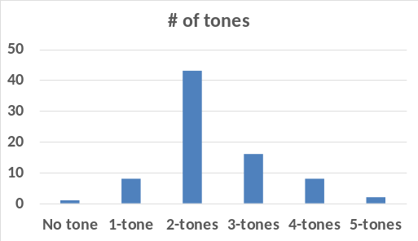
Figure 7:
The Figure shows the number of tones in a writing. More than 42 writings (around 54.43%) have two tones and 16 (20.25%) writings have three tones. There are 8 writings each which have single tone and four tones.

Limitations
This is a qualitative and exploratory study and forms the foundation of further initiatives and research. It only takes into account one specific course with around 79 students. Alos, writings are rather short and might have deviation from actual score as some test may require a substantial sample of text in order to be considered a valid measure of difficulty.

Conclusion
Guided by these assumptions, teachers of engineering students can make efforts to first analyse the writing of the students and then appeal to the ways in which engineers think.

References
- M. J. Riemer, "Communication skills for the 21st century engineer," Global J. of Eng. Educ., vol. 11, pp. 89-100, 2007.
- E. Baum, "Engineering accreditation in the USA – Criteria 2000," in Proc. 2nd Global Congr. on Eng. Educ., 2000, pp.17-20.
- A. A. Anwar, D. J. Richards, and C. Eng, "Comparison of EC and ABET Accreditation Criteria," Journal of Professional Issues in Engineering Education and Practice, vol. 144, p. 06018001, 2018
- J. Trevelyan and B. Williams, "Value creation in the engineering enterprise: an educational perspective," European Journal of Engineering Education, pp. 1-23, 2018.
- R. Goldsmith and K. Willey, "The otherness of writing in the engineering curriculum: A practice architectures perspective," Journal of Academic Language and Learning, vol. 12, pp. A97-A114, 2018.
- H. P. Jensen, "Strategic planning for the education process in the next century," Global J. of Eng. Educ., vol. 4, pp. 35-42, 2000.
- D. B. Lenard and L. Pintarić, "Communication skills as a prerequisite for the 21st century engineer," ELT Vibes: International E-Journal for Research in ELT, vol. 4, p. 11, 2018.
- A. Krasniewski, "Teaching technical communication–unexpected experience," in Proc. Int. Conf. on Eng. Educ., 2001. Oslo, Norway, 6B3-14- 6B3-19.
- W. Dorothy, "Using writing to structure agency: An examination of engineers' practice.," Technical Communication Quarterly 15, no. 4 (2006): 411-430.
- E. Godfrey and L. Parker, "Mapping the Cultural Landscape in Engineering Education," Journal of Engineering Education, vol. 99, pp. 5-22, 2010.
- M. W. Milke, C. Upton, G. F. Koorey, A. D. O'Sullivan, and K. Comer, "Improving the writing of engineering students through portfolios," In ASEE Annual Conference and Exposition, Conf. Proceedings. 2013.
- S. Nikolic, D. Stirling, and M. Ros, "Formative assessment to develop oral communication competency using YouTube: self- and peer assessment in engineering," European Journal of Engineering Education, Vol. 43,. pp. 538-551, 2018.
- M. Stîngu and S. Iftimescu, "Changing Pedagogy: The Use of Technology in Educational Support Programs," in The International Scientific Conference eLearning and Software for Educ., 2016, pp. 101.
- M. E. Wilson, "Teaching, learning, and millennial students," New directions for student services 2004, no. 106, pp. 59-71, 2004.
- C. Crook, C. Harrison, L. Farrington-Flint, C. Tomás, and J. Underwood (2010, September). The impact of technology: Value-added classroom practice, [Online]. Available: http://www.becta.org.uk
- J. C. C. Fuh and A. Paul, "Tuning into Gen-Y Learners: An Engagement Catalyst." GSE E-Journal of Education, vol. 3, pp. 1-18, 2015.
- C. Schofield and S. Honore, "Generation Y and learning," The Ashridge Journal, pp. 26-32, 2010.
- Association of American Colleges and. Universities. 2005 "Liberal Education Outcomes: A Preliminary Report on Student Achievement in College," Washington, DC: Assoc. of Amer. Colleges and. Universities.
- L. Tsui, "Fostering critical thinking through effective pedagogy: Evidence from four institutional case studies," The Journal of Higher Education, vol. 73, pp. 740-763, 2002.
- O. Kågesten and J. Engelbrecht, "Supplementary explanations in undergraduate mathematics assessment: A forced formative writing activity," European J. of Eng. Education, vol. 31, pp. 705-715, 2006.
- P. Raju and C. S. Sankar, "Teaching Real‐World Issues through Case Studies," Journal of Engineering Education, vol. 88, pp. 501-508, 1999.
- L. Flower, “Problem-solving strategies for writing”. Chicago, IL: Harcourt Brace Jovanovich, 1989
- P. Tynjälä, L. Mason, and K. Lonka, "Writing as a learning tool: An introduction," in Writing as a learning tool, Dordrecht: Springer, 2001, pp. 7-22.
- C. C. Bonwell and J. A. Eison, Active Learning: Creating Excitement in the Classroom. ASHE-ERIC Higher Educ. Reports: ERIC, 1991. The George Washington University, Washington, DC.
- C. Meyers and T. B. Jones, Promoting Active Learning. Strategies for the College Classroom: San Francisco: Josey-Bass, 1993.
- J. M. Keller, "Development and use of the ARCS model of instructional design," Journal of instructional development, vol. 10, pp. 2-10, 1987.
- P. Race, "Practical pointers on peer assessment,"in Peer Assessment in Practice, S. Brown, Ed. Birmingham: SEDA, 1998, pp.113-122.
- D. A. Haaga, "Peer review of term papers in graduate psychology courses," Teaching of Psychology, vol. 20, pp. 28-32, 1993.
- J. T. Shaplin and H. F. Olds, Team teaching: Harper & Row, 1964.
- M. S. Wenger and M. J. Hornyak, "Team teaching for higher level learning: A framework of professional collaboration," Journal of Management Education, vol. 23, pp. 311-327, 1999.
- S. Toohey, Designing courses for higher education: McGraw-Hill Education (UK), 1999.
- D. R. Thomas, "A general inductive approach for qualitative data analysis: American journal of evaluation, vol. 27, pp. 237-246, 2006.
- S. M. Strohm and R. A. Baukus, "Strategies for fostering critical-thinking skills," Journalism & Mass Communication Educator, vol. 50, pp. 55-62, 1995

